**Hindusthan College of Engineering and Technology**

An Autonomous Institution, Approved by AICTE, New Delhi, Affiliated to Anna University, Chennai

Valley Campus, Coimbatore – 641 032, Tamil Nadu, INDIA

**DEPARTMENT OF INFORMTION TECHNOLOGY**

INTERNSHIP – REPORT

2024 - 2025

**“TITLE OF PROJECT INTERNSHIP”**

**PROJECT DOMAIN**

**COMPANY NAME**

*Submitted By*

STUDENT NAME – REG/ROLL NO

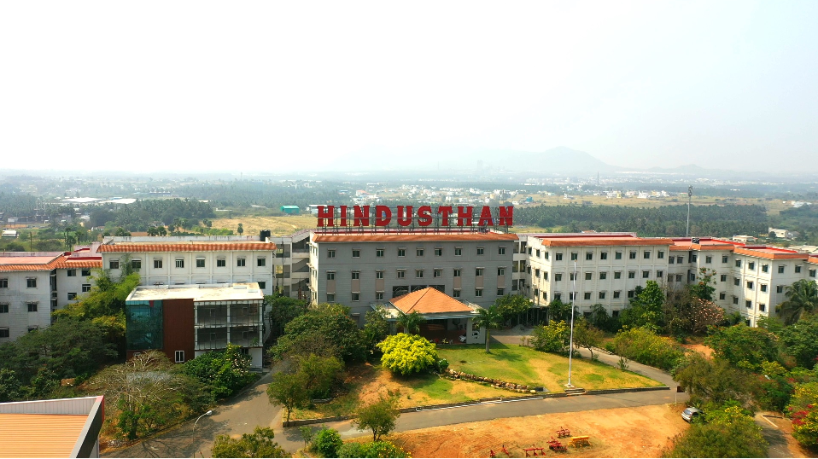

**Hindusthan College of Engineering and Technology**

An Autonomous Institution, Approved by AICTE, New Delhi, Affiliated to Anna University, Chennai

Valley Campus, Coimbatore – 641 032, Tamil Nadu, INDIA

**DEPARTMENT OF INFORMATION TECHNOLOGY**

**DECLARATION**

This is to certify that the Internship report submitted by **Student Name (Register No)** is the Bonafide record of the **Information Technology** student who visited Company name for Project Title - Internship during the Even semester of the academic year 2024-2025**.**

|  |  |
| --- | --- |
| ***Class advisor*** | ***Head of the department*** |
| Mr.Praveen Kumar R  Assistant Professor  Department of Information Technology  Hindusthan College of Engineering and Technology,  Coimbatore-641032 | Dr. M.Sabrigiriraj  Professor and Head  Department of Information Technology  Hindusthan College of Engineering and Technology,  Coiumbatore-641032 |

**Hindusthan College of Engineering and Technology**

An Autonomous Institution, Approved by AICTE, New Delhi, Affiliated to Anna University, Chennai

Valley Campus, Coimbatore – 641 032, Tamil Nadu, INDIA

**DEPARTMENT OF INFORMATION TECHNOLOGY**

**CHECK LIST**

* Acknowledgement
* Internship Offer Letter from Company
* Internship Completion Certificate
* Internship Report

**Hindusthan College of Engineering and Technology**

An Autonomous Institution, Approved by AICTE, New Delhi, Affiliated to Anna University, Chennai

Valley Campus, Coimbatore – 641 032, Tamil Nadu, INDIA

**DEPARTMENT OF INFORMATION TECHNOLOGY**

**ACKNOWLEDGEMENT**

I would like to express my sincere gratitude to all the people and organizations that contributed to the success of my internship experience. This internship has been an invaluable learning opportunity, and I would not have been able to accomplish it without the guidance, support, and encouragement from various individuals and organizations.

I would like to thank **[Company Name]** for providing me with the opportunity to be part of their team. I am especially grateful to my **internship supervisor, [Supervisor's Name]**, for their continuous support, mentorship, and for offering valuable insights into the industry. Their expertise and guidance helped me develop both professionally and personally, and I greatly appreciate the time and effort they invested in my learning.

I would also like to extend my gratitude to the entire team at **[Company Name]**, whose cooperation and willingness to share their knowledge made my internship experience incredibly enriching. The collaborative work environment allowed me to apply the skills I have learned in my academic journey and gain hands-on experience in the field.

I am deeply thankful to my **college principal**, **Dr.J.Jaya** for their support in granting me the opportunity to pursue this internship and for their continuous encouragement throughout my academic journey. Their leadership and guidance have been crucial in shaping my educational experience.

My heartfelt thanks also go to my **Head of Department, Dr. M.Sabrigiriraj**  and my **Class Advisor, Mr.R.Praveen Kumar.R**, for their valuable advice, encouragement, and assistance in making this internship possible. Their belief in the importance of practical experience in enhancing academic learning has been a guiding force in this endeavor.

I would also like to express my sincere appreciation to my **friends** and **family** for their unwavering support throughout my internship. Their encouragement, understanding, and belief in me have been a constant source of motivation.

Finally, I would like to thank everyone who helped and supported me during this internship for making this experience one of the most rewarding and educational chapters of my life.

**INTERNSHIP REPORT**

INDEX

S.No Table of Content Page No

1 Introduction

2 Company Profile

3 Technology Used

4 Module Description

4.1

5 Screen Sort

6 Sample Coding

7 Conclusion